天津理工大学实验报告
学院（系）名称：管理学院
姓名 | 刘瑞 |  | 学号 | 20163346 |  | 专业 |  | 信息管理与信息系统
班级 | 2班 |  | 实验项目 | 实验九：新闻发布系统的开发
课程名称 |  | WEB程序设计 |  |  | 课程代码 |  | 0961003
实验时间 |  | 2019-06-11、2019-06-14 |  |  | 实验地点 |  | 24-209
批改意见 |  |  |  |  | 成绩
教师签字：

- 新闻发布系统用户注册的实现
- “index.php”“点击注册”跳转到注册界面“register.php”
<html>
<head>
<title>
欢迎访问新闻发布系统！
</title>
<link rel="stylesheet" href="css/news.css" type="text/css">
</head>
<body>
<div id="container">
<div id="header">
<div id="menu">
<ul>
......
</ul>
</div>
<div id="banner">
</div>
</div>
<div id="pagebody">
<div id="sidebar">
<div id="login">
<br>
<?php
include_once("login.php");
?>
<a href="index.php?url=register.php">点此注册</a>
</div>
</div>
<div id="mainbody">
<div id="mainfunction">
<br>
<?php
if(isset($_GET["url"])){
$url = $_GET["url"];
}else{
$url = "news_list.php";
}
include_once($url);
?>
</div>
</div>
<div style="clear:both;">
</div>
</div>
<div id="footer">
......
</div>
</div>
</body>
</html>
<script>
……
</script>
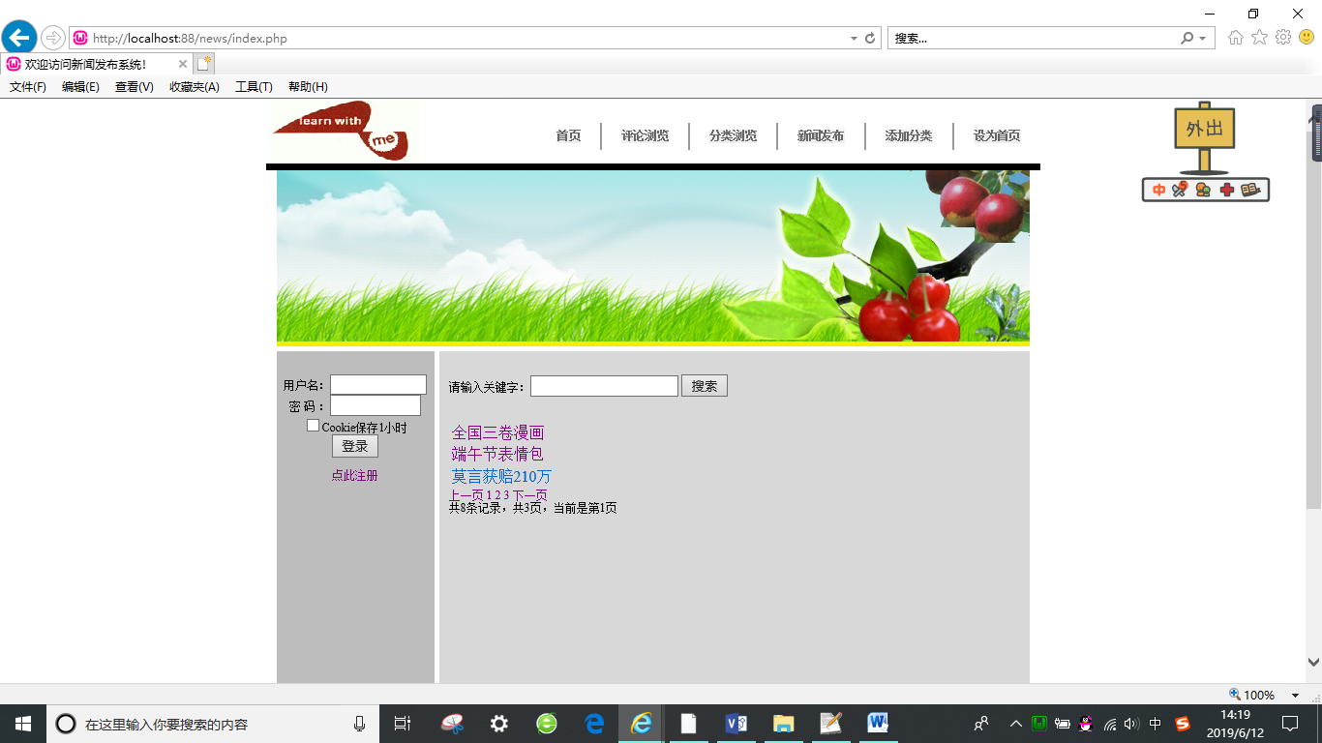
- “register.php”
<html>
<!-- 定义输入表单样式 -->
<style type="text/css">
html{font-size: 12px;}
fieldset{width:200px;margin:0 auto;}
legend{font-weight: bold; font-size: 14px;}
label{float:left; width:70px; margin-left:10px;}
.left{margin-left:80px;}
.input{width:150px;}
span{color: #666666;}
</style>
<!-- 验证表单是否输入 -->
<script type="text/javascript">
function InputCheck(reg){
if(reg.name.value==''){
alert('请输入用户名！');
reg.name.focus();
return (false);
}
if(reg.password.value==''){
alert('请输入密码！');
reg.password.focus();
return (false);
}
}
</script>
<body>
<form name="reg" method="post" action="index.php?url=checkregister.php" onSubmit="return InputCheck(this)">
<p>
<lable for="name" class="lable">用户名：</lable>
<input id="name" name="name" type="text" class="input" />
</p>
<p>
<lable for="password" class="lable">密 码：</lable>
<input id="password" name="password" type="text" class="input" />
</p>
<p>
<input name="submit" value="注册" type="submit" />
</p>
</form>
</body>
</html>
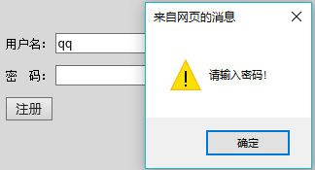
- 填写完成后点击“注册”跳转到“checkregister.php”进行检查
<?php
include_once("functions/database.php");
$name = $_POST["name"];
$password = $_POST["password"];
mysql_select_db("news");
//检测用户名是否存在
$sql = "select * from users where name = '$name'";
get_connection();
$resultSet = mysql_query($sql);
if (mysql_num_rows($resultSet) > 0) {
exit("用户名已被占用，请更换其他用户名");
}
//插入数据
$password = md5(md5("$name"));
mysql_query("insert into users values(null,'$name','$password')");
$userID = mysql_insert_id();
$userSQL = "select * from users where user_id = '$userID'";
$userResult = mysql_query($userSQL);
if ($user = mysql_fetch_array($userResult)) {
echo "您的注册用户名为：" . $user['name'];
} else {
exit("用户注册失败！");
}
close_connection();
?>
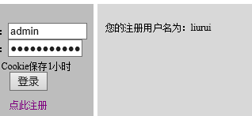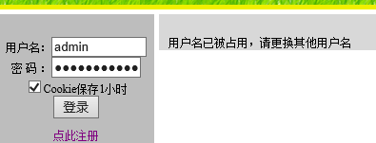
- 新闻发布系统分类浏览的实现
- “分类浏览”页面“category_list.php”
<?php
include_once("functions/database.php");
include_once("functions/page.php");
include_once("functions/is_login.php");
if (!session_id()){//这里使用session_id()判断是否已经开启了Session
session_start();
}
if(!is_login()){
echo "请您登录系统后，再访问该页面！";
return;
}
?>
<br/>
<form action="index.php?url=news_select.php" method="post" enctype="multipart/form-data">
类别：
<select name="category_id" size="1">
<?php
include_once("functions/database.php");
get_connection();
$result_set = mysql_query("select * from category");
close_connection();
while($row = mysql_fetch_array($result_set)){
?>
<option value="<?php echo $row['category_id'];?>"><?php echo $row['name'];?></option>
<?php
}
?>
</select>
<input type="submit" value="查询">&nbsp;<input type="reset" value="重置">
</form>
<table>
<?php
$result_sql = "select * from category";
get_connection();
$result_set = mysql_query($result_sql);
close_connection();

if(mysql_num_rows($result_set)==0){
exit("暂无记录！");
}
while($row = mysql_fetch_array($result_set)){
?>
<tr>
<td>
<?php echo $row["name"]?>&nbsp;&nbsp;&nbsp;
</td>
<?php
if(is_login()){
?>
<td>
<a href="index.php?url=category_edit.php&category_id=<?php echo $row['category_id']?>">编辑</a>
</td>
<td>
<a href="index.php?url=category_delete.php&category_id=<?php echo $row['category_id']?>" onclick="return confirm('确定删除吗？');">删除</a>
</td>
<?php
}
?>
</tr>
<?php
}
?>
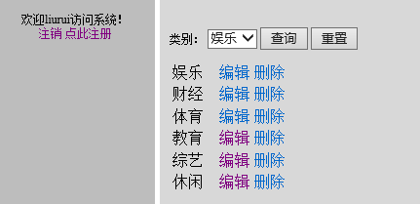
</table>
- 添加分类
“category_add.php”
<?php
include_once("functions/is_login.php");
if (!session_id()){//这里使用session_id()判断是否已经开启了Session
session_start();
}
if(!is_login()){
echo "请您登录系统后，再访问该页面！";
return;
}
?>
<form action="category_save.php" method="post" enctype="multipart/form-data">
类别：<input type="text" size="20" name="name">
<input type="submit" value="添加"><input type="reset" value="重置">
</form>

“category_save.php”
<?php
include_once("functions/is_login.php");
session_start();
if(!is_login()){
echo "请您登录系统后，再访问该页面！";
return;
}
include_once("functions/database.php");
$name=$_POST["name"];
include_once("functions/database.php");
$sql = "insert into category values(null,'$name')";
get_connection();
mysql_query($sql);
close_connection();
$message = "分类信息添加成功！";
header("Location:index.php?url=news_list.php&message=$message");
?>
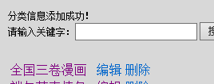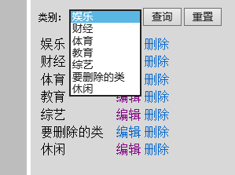
- 删除分类“category_delete.php”
<?php
include_once("functions/is_login.php");
if (!session_id()){//这里使用session_id()判断是否已经开启了Session
session_start();
}
if(!is_login()){
echo "请您登录系统后，再访问该页面！";
return;
}
include_once("functions/database.php");
$category_id = $_GET["category_id"];
get_connection();
mysql_query("delete from category where category_id=$category_id");
close_connection();
$message = "分类信息删除成功！";
header("Location:index.php?url=news_list.php&message=$message");
?>
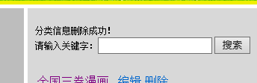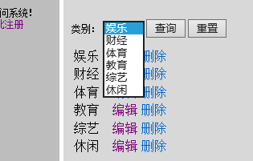
- 对新闻按分类进行查询：“news_select.php”
<?php
include_once("functions/is_login.php");
if (!session_id()){//这里使用session_id()判断是否已经开启了Session
session_start();
}
if(!is_login()){
echo "请您登录系统后，再访问该页面！";
return;
}
?>
<?php
include_once("functions/database.php");
get_connection();
$category_id = $_POST["category_id"];
$sql_category = "select * from news where category_id=$category_id";
$result_set= mysql_query($sql_category);
close_connection();
if(mysql_num_rows($result_set)==0){
exit("暂无记录！");
}
while($row = mysql_fetch_array($result_set)){
?>
<table>
<tr>
<td>
<a href="index.php?url=news_detail.php&news_id=<?php echo $row['news_id']?>"><?php echo mb_strcut($row['title'],0,40,"gbk")?></a>
</td>
<?php
if(is_login()){
?>
<td>
<a href="index.php?url=news_edit.php&news_id=<?php echo $row['news_id']?>">编辑</a>
</td>
<td>
<a href="index.php?url=news_delete.php&news_id=<?php echo $row['news_id']?>" onclick="return confirm('确定删除吗？');">删除</a>
</td>
<?php
}
?>
</tr>
<?php
}
?>
</table>

- 对分类进行修改
 “category_edit.php”
<?php
include_once("functions/is_login.php");
if (!session_id()){//这里使用session_id()判断是否已经开启了Session
session_start();
}
if(!is_login()){
echo "请您登录系统后，再访问该页面！";
return;
}
include_once("functions/database.php");
$category_id = $_GET["category_id"];
get_connection();
$result_category = mysql_query("select * from category where category_id=$category_id");
close_connection();
$category = mysql_fetch_array($result_category);
?>
<form action="category_update.php" method="post">
类别： <input type="text" size="20" name="name" value="<?php echo $category['name']?>">
<input type="hidden" name="category_id" value="<?php echo $category_id?>">
<input type="submit" value="修改">
<input type="button" value="取消" onclick="window.history.back();">
</form>

“category_update.php”
<?php
include_once("functions/is_login.php");
if(!session_id()){//这里使用session_id()判断是否已经开启了Session
session_start();
}
if(!is_login()){
echo "请您登录系统后，再访问该页面！";
return;
}
include_once("functions/database.php");
$name = $_POST["name"];
$category_id = $_POST["category_id"];
$sql = "update category set name='$name' where category_id=$category_id";
get_connection();
mysql_query($sql);
close_connection();
$message = "分类信息修改成功！";
header("Location:index.php?url=news_list.php&message=$message");
?>
