天津理工大学实验报告
学院（系）名称：管理学院
姓名 | 常小林 |  | 学号 | 20163368 |  | 专业 |  | 信息管理与信息系统
班级 | 2班 |  | 实验项目
课程名称 |  |  |  |  | 课程代码
实验时间 |  |  |  |  | 实验地点 |  | 24-209
批改意见 |  |  |  |  | 成绩
教师签字：

分类浏览模块实现：
<form action="#" method="post" enctype="multipart/form-data">
选择类别：
<select name="category_id" size="1">
<?php
include_once("functions/database.php");
get_connection();
$result_set = mysql_query("select * from category");
close_connection();
while($row = mysql_fetch_array($result_set)){
?>
<option value="<?php echo $row['category_id'];?>"><?php echo $row['name'];?></option>
<?php
}
?>
</select><br/>
<input type="submit" value="选择"></form>
<?php
include_once("functions/database.php");
$category_id = $_POST["category_id"];
$sql = "select * from news where category_id=$category_id";
get_connection();
$result_set = mysql_query($sql);
close_connection();
echo "该新闻如下：<br/>";
while($row = mysql_fetch_array($result_set)){
echo "内容：".$row["content"]."<br/>";
echo "日期：".$row["publish_time"]."<br/>";
echo "标题：".$row["title"]."<hr/>";
}
?>
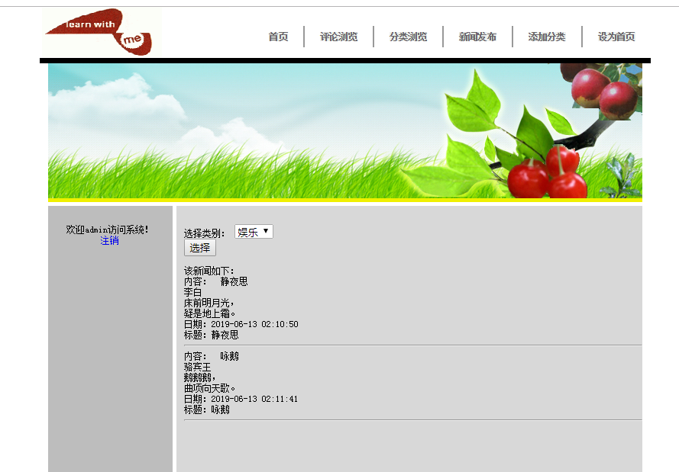

添加分类模块实现：
<form action="#" method="post" enctype="multipart/form-data">
选择类别：
<select name="category_id" size="1">
<?php
include_once("functions/database.php");
get_connection();
$result_set = mysql_query("select * from category");
close_connection();
while($row = mysql_fetch_array($result_set)){
?>
<option value="<?php echo $row['category_id'];?>"><?php echo $row['name'];?></option>
<?php
}
?>
</select><br/>
<input type="submit" value="选择"></form>
<?php
include_once("functions/database.php");
$category_id = $_POST["category_id"];
$sql = "select * from news where category_id=$category_id";
get_connection();
$result_set = mysql_query($sql);
close_connection();
echo "该新闻如下：<br/>";
while($row = mysql_fetch_array($result_set)){
echo "内容：".$row["content"]."<br/>";
echo "日期：".$row["publish_time"]."<br/>";
echo "标题：".$row["title"]."<hr/>";
}
?>