天津理工大学实验报告
学院（系）名称：管理学院
姓名 | 贾雅婷 |  | 学号 | 20163322 |  | 专业 |  | 信息管理与信息系统
班级 | 1班 |  | 实验项目 | 实验九：新闻发布系统的开发
课程名称 |  | WEB程序设计 |  |  | 课程代码 |  | 0961003
实验时间 |  | 2019-06-11,2019-06-14 |  |  | 实验地点 |  | 24-209
批改意见 |  |  |  |  | 成绩
教师签字：

1、管理分类功能：
category_add.php
<?php
include_once("functions/is_login.php");
if (!session_id()){//这里使用session_id()判断是否已经开启了Session
session_start();
}
if(!is_login()){
echo "请您登录系统后，再访问该页面！";
return;
}
?>
<form action="category_save.php" method="post" enctype="multipart/form-data">
分类名称： <input type="text" size="60" name="name"><br/>
<input type="submit" value="添加">
</form>
</br>
<?php
include_once("functions/database.php");
include_once("functions/page.php");
$sql = "select * from category";
get_connection();
//分页的实现
$result_news = mysql_query($sql);
$total_records = mysql_num_rows($result_news);
$page_size = 8;
if(isset($_GET["page_current"])){
$page_current = $_GET["page_current"];
}else{
$page_current = 1;
}
$start = ($page_current-1)*$page_size;
$result_sql = "select * from category order by category_id desc limit $start,$page_size";
$result_set = mysql_query($result_sql);
close_connection();
echo "分类如下：<br/>";
while($row = mysql_fetch_array($result_set)){
echo "分类编号：".$row["category_id"]."<br/>";
echo "分类名：".$row["name"]."&nbsp;&nbsp;";
?>
<a href="index.php?url=category_delete.php&category_id=<?php echo $row['category_id']?>" onclick="return confirm('确定删除吗？');">删除</a>
<!-- echo "<a href='category_delete.php?category_id=".$row["category_id"]."onclick="return confirm('确定删除吗？')">删除</a>"; -->
<?php echo "&nbsp;&nbsp;&nbsp;";?>
<a href="index.php?url=category_edit.php&category_id=<?php echo $row['category_id']?>">编辑</a>
<!-- echo "<a href='category_edit.php?category_id=".$row["category_id"]."' >编辑</a>"; -->
<?php echo "<hr/>";
}
//分页的实现
$url = "index.php?url=category_List.php";
page($total_records,$page_size,$page_current,$url,"");
?>
category_save.php
<?php
include_once("functions/is_login.php");
include_once("functions/database.php");
session_start();
if(!is_login()){
echo "请您登录系统后，再访问该页面！";
return;
}
$name = $_POST["name"];
$sql = "insert into category values(null,'$name')";
get_connection();
mysql_query($sql);
close_connection();
header("Location:index.php?url=category_add.php");
// 设置跳转 GET[]获取url的信息
?>
category_save.php
<?php
include_once("functions/is_login.php");
include_once("functions/database.php");
session_start();
if(!is_login()){
echo "请您登录系统后，再访问该页面！";
return;
}
$name = $_POST["name"];
$sql = "insert into category values(null,'$name')";
get_connection();
mysql_query($sql);
close_connection();
header("Location:index.php?url=category_add.php");
// 设置跳转 GET[]获取url的信息
?>
运行结果：

- 修改分类
category_edit.php
<?php
include_once("functions/is_login.php");
if (!session_id()){//这里使用session_id()判断是否已经开启了Session
session_start();
}
if(!is_login()){
echo "请您登录系统后，再访问该页面！";
return;
}
include_once("functions/database.php");
$category_id = $_GET["category_id"];
get_connection();
$result_category = mysql_query("select * from category where category_id=$category_id");
close_connection();
$category = mysql_fetch_array($result_category);
?>
<form action="category_update.php" method="post">
类名： <input type="text" size="60" name="name" value="<?php echo $category['name']?>"><br/>
<input type="hidden" name="category_id" value="<?php echo $category_id?>">
<input type="submit" value="修改">
<input type="button" value="取消" onclick="window.history.back();">
</form>
ategory_update.php
<?php
include_once("functions/is_login.php");
if(!session_id()){//这里使用session_id()判断是否已经开启了Session
session_start();
}
if(!is_login()){
echo "请您登录系统后，再访问该页面！";
return;
}
include_once("functions/database.php");
$category_id = $_POST["category_id"];
$name = $_POST["name"];
$sql = "update category set name='$name' where category_id=$category_id";
get_connection();
mysql_query($sql);
close_connection();
header("Location:index.php?url=category_add.php");
?>
运行结果：

- 删除分类：
category_delete.php
<?php
include_once("functions/is_login.php");
if (!session_id()){//这里使用session_id()判断是否已经开启了Session
session_start();
}
if(!is_login()){
echo "请您登录系统后，再访问该页面！";
return;
}
include_once("functions/database.php");
$category_id = $_GET["category_id"];
get_connection();
mysql_query("delete from category where category_id=$category_id");
mysql_query("delete from news where category_id=$category_id");
close_connection();
header("Location:index.php?url=category_add.php");
?>
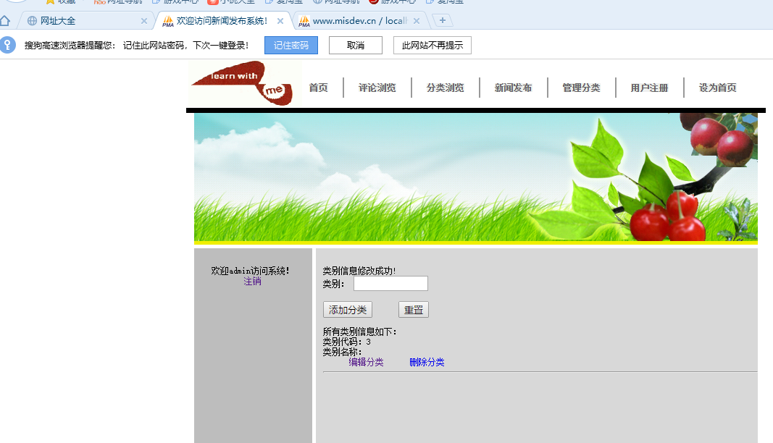
2、用户注册功能：
register.php
<form action="register_save.php" method="post">
<p>用户注册<p>
用 户 名：<input type="text" name="userName"><br/>
密&nbsp; 码 ：<input type="password" name="password" ><br/>
<input type="submit" value=" 提 交 ">
<input type="reset" value=" 重 填 ">
</form>
register_save.php
<?php
include_once("functions/database.php");
$name = $_POST["userName"];
$password = md5(md5($_POST["password"]));
$sql="insert into users values(null,'$name','$password')";
get_connection();
mysql_query($sql);
close_connection();
header("Location:index.php?url=news_list.php");
?>
